**CHAPTER 1: INTRODUCTION**

**1.1 Aim of Project & Objective –** Books have always been a source of knowledge, entertainment, and inspiration. With the advent of technology, the way we choose and access books has transformed significantly. Today, digital platforms offer users an abundance of options, often leading to an overwhelming experience in deciding what to read next. This scenario emphasizes the importance of recommendation systems that simplify the decision-making process by suggesting books tailored to individual preferences.

The Book Recommendation System aims to enhance the user experience by providing personalized suggestions based on user behavior and popular trends. This project employs machine learning algorithms to analyze large datasets of user ratings, book metadata, and reading patterns. By integrating Popularity-Based Filtering and Collaborative Filtering techniques, the system offers a robust mechanism to recommend books suited to both new users and returning enthusiasts.

A unique aspect of this project is its adaptability to cater to diverse user needs. For instance, while a casual reader may benefit from recommendations based on global popularity, avid readers may prefer personalized suggestions derived from their historical data. This system is designed to balance simplicity with technical sophistication, ensuring ease of use without compromising on accuracy and relevance.

The Book Recommendation System also serves as a practical demonstration of the power of machine learning in everyday applications. Beyond the technical implementation, the project highlights the intersection of technology and creativity, showcasing how algorithms can contribute to enriching cultural and intellectual pursuits.

Books have always been an essential part of human culture, serving as sources of knowledge, entertainment, and inspiration across generations. With the rapid advancements in technology, the way people discover and consume books has undergone a significant transformation. Digital platforms now offer vast libraries of content at the click of a button, presenting users with an overwhelming array of choices. This creates a need for intelligent systems that assist users in navigating these vast options effectively, ensuring they find books that resonate with their preferences and interests.

The Book Recommendation System aims to address this challenge by leveraging advanced machine learning techniques to enhance the user experience .

**1.2 Background of Project**

The primary aim of the Book Recommendation System is to develop a reliable and efficient tool that enhances the user experience by providing personalized book recommendations. This involves achieving the following goals:

Personalized Suggestions: Leverage collaborative filtering techniques to understand individual user preferences and provide tailored book recommendations.

Popularity-Based Recommendations: Create a mechanism to identify and showcase highly rated and widely read books for users who may not have specific preferences.

User-Friendly Interface: Develop an intuitive and responsive web-based interface that allows users to interact seamlessly with the recommendation system.

Data-Driven Insights: Utilize advanced data processing and machine learning algorithms to analyze user ratings and book metadata, ensuring accurate and meaningful recommendations.

Scalability and Adaptability: Ensure the system can handle a large volume of data and adapt to new inputs, such as additional books, ratings, or user behaviors.

This project aims to bridge the gap between readers and their next favorite books, creating a positive and engaging experience for a wide range of users, from casual readers to avid bibliophiles. It sets the foundation for future advancements, including hybrid models, integration with real-time user data, and enhanced personalization through cutting-edge technologies

The Book Recommendation System is a sophisticated tool designed to transform how users discover and select books. With the exponential growth of digital libraries and online book platforms, the sheer volume of options available to readers can often feel overwhelming. This project aims to bridge the gap between readers and their next great read, offering personalized, meaningful, and enjoyable book recommendations that cater to diverse reading preferences.

This project is more than just a recommendation engine; it’s a step towards redefining how readers engage with books in the digital age. By leveraging cutting-edge technologies such as Machine Learning, NLP, and Big Data Analytics, the Book Recommendation System provides an intersection of technology and literature.

**CHAPTER 2: LITERATURE SURVEY**

**2.1 Literature Survey**

Book recommendation systems have significantly evolved, driven by advancements in machine learning and data analytics. Early recommendation systems were relatively simplistic, relying on manual tagging and basic content matching. Over time, more sophisticated algorithms were developed, especially as the amount of available data grew exponentially. Among the most prominent techniques for building Collaborative filtering has become one of the most widely used techniques for generating personalized recommendations. This approach works by leveraging user behavior, such as ratings, clicks, or purchases, to find patterns and make predictions about what books a user might like. Collaborative filtering can be categorized into two types: **user-based** and **item-based** filtering. **User-based collaborative filtering** suggests items based on the preferences of users with similar tastes, while **item-based collaborative filtering** recommends books that are similar to those a user has liked in the past.

The effectiveness of collaborative filtering was highlighted by **Sarwar et al. (2001)**, who demonstrated its success in movie recommendation systems. However, collaborative filtering suffers from challenges such as the **cold start problem**, where new users or items do not have enough data for accurate recommendations, and **sparsity**, which occurs when users interact with only a small portion of available items, leading to a less reliable system.

Despite these limitations, collaborative filtering has been a foundational approach in recommendation systems, particularly when combined with other techniques. **Ricci et al. (2011)** further explored ways to improve collaborative filtering by integrating it with other data sources and models to enhance prediction accuracy.

**Popularity-Based Recommendations**

Another approach widely used in recommendation systems, particularly for new users or when dealing with a lack of data, is **popularity-based recommendation**. Popularity-based methods recommend books that are generally well-received or highly rated by a large number of users. This approach bypasses the need for personalized data by simply selecting items that have garnered the most attention or positive reviews, assuming that widely popular items are likely to appeal to a broad audience.

Popularity-based systems are commonly seen in e-commerce platforms and streaming services, as they are easy to implement and provide quick results.

**Mobasher et al. (2007)** highlighted the utility of such systems in providing initial recommendations when user data is insufficient. However, while these systems can serve as a useful starting point, they often lack the precision needed for long-term user engagement, as they fail to account for individual preferences and niche interests. recommendation systems are collaborative filtering and popularity-based approaches.

**Challenges in Book Recommendation Systems**

Despite the advantages of collaborative filtering and popularity-based methods, challenges still persist in the realm of book recommendations. A significant challenge is the **diversity of recommendations**, as users often receive similar suggestions based on their past preferences, which can limit discovery. **Li et al. (2021)** noted that such systems may lead to recommendation "bubbles," where users are continuously recommended books within a narrow genre or author pool, hindering the exploration of new topics.

Additionally, **bias** is another concern in recommendation systems. Popularity-based methods can perpetuate biases toward mainstream books, neglecting lesser-known authors or niche genres. **Binns et al. (2018)** emphasized the need for fairer recommendation algorithms that account for a broader range of content. As a result, addressing these biases is crucial for maintaining a diverse and inclusive recommendation environment.

**Gaps and Opportunities**

Although the combination of collaborative filtering and popularity-based methods offers a solid foundation for personalized book recommendations, there is ample opportunity to refine these techniques. Future enhancements could incorporate more sophisticated user data analysis, including sentiment analysis of book reviews, and improve the diversity of recommendations through better model tuning and exploration strategies.

The *Next Chapter* platform uses a hybrid approach of collaborative filtering and popularity-based recommendations to provide a more robust, user-centered solution. By combining these two methods, the platform aims to deliver accurate, engaging, and diverse book suggestions to readers, addressing both the personalization and scalability challenges faced by earlier systems.

**CHAPTER 3: METHODOLOGY**

**3.1 Methodology**

The methodology for the *Next Chapter* platform involves the integration of various techniques and tools to develop a personalized and effective book recommendation system. The system combines collaborative filtering and popularity-based recommendation approaches to provide accurate, relevant, and diverse book suggestions to users. The process includes data collection, user profile creation, recommendation generation, and evaluation.

1. Data Collection

The first step in building the recommendation system is gathering the required data. The system collects data from two main sources:

User Data: This includes user interactions such as ratings, search history, browsing history, and book preferences. New users create profiles where they input basic information, including preferred genres, authors, and book types.

Book Data: The book dataset includes information about each book, such as the title, author, genre, and average user rating. External APIs, such as Google Books or Open Library, are used to gather metadata for books. In addition, user-generated content such as book reviews and ratings are stored in the database.

2. Data Preprocessing

Data preprocessing is crucial for preparing the collected data for analysis and model training. The following preprocessing steps are applied:

Cleaning: Missing or incomplete user profiles and book information are handled by filling in or removing null entries.

Normalization: Ratings are normalized to a consistent scale, typically from 1 to 5, to ensure uniformity across users and items.

Feature Engineering: Additional features such as book genre, author, and publication year are extracted from the book metadata and stored in the system. These features help the recommendation models identify patterns and make better predictions.

Collaborative filtering is used to make recommendations based on the collective preferences of users. There are two primary methods of collaborative filtering:

3. Recommendation Algorithm

The platform uses a hybrid approach combining **collaborative filtering** and **popularity-based** recommendation techniques. Each approach contributes to generating accurate and diverse recommendations for users.

Collaborative Filtering

Collaborative filtering is used to make recommendations based on the collective preferences of users. There are two primary methods of collaborative filtering:



**Figure 1 . Collaborative Filtering**

User-Based Collaborative Filtering (UBCF): This method identifies users who have similar preferences and recommends books based on the ratings and interactions of those similar users. For instance, if User A and User B have a high overlap in their rated books, User A’s unrated books may be recommended to User B.

Item-Based Collaborative Filtering (IBCF): This method finds similarities between items (books) and recommends books that are similar to the ones the user has rated or interacted with in the past. For example, if User A liked Book X, the system would recommend other books similar to Book X.

To implement collaborative filtering, the platform uses libraries such as Surprise or scikit-learn for matrix factorization and nearest neighbor approaches. The Cosine Similarity or Pearson Correlation methods are used to compute the similarity between users or items.

Popularity-Based Recommendations

The popularity-based recommendation system generates book suggestions by recommending items that have the highest ratings or most user interactions. This is especially useful for new users who have not yet interacted with enough items for personalized recommendations. Popularity-based systems rely on global data to provide suggestions that are likely to appeal to the general audience.

The methodology for this includes:

Top-Rated Books: Books with the highest average ratings across all users are recommended to new users.

Trending Books: Books that have gained attention in a specific time period (e.g., books that have received a spike in user activity) are recommended to users.

5. Model Evaluation

Evaluating the performance of the recommendation algorithms is essential for ensuring their effectiveness. The platform uses various metrics to assess the quality of the recommendations, including:

Precision: Measures how many of the recommended books are relevant to the user. Higher precision means that fewer irrelevant books are included in the recommendations.

Recall: Measures how many relevant books are recommended out of all the relevant books available. Higher recall indicates that the system is good at finding and suggesting a broad range of relevant books.

F1-Score: The harmonic mean of precision and recall, providing a balanced evaluation of the recommendation system.

Mean Average Precision (MAP): Measures the ranking quality of the recommendations. Higher MAP values indicate that relevant books appear higher in the recommendation list

6. System Deployment

The backend is developed using **Flask**, a lightweight Python framework, ensuring efficient handling of user requests and database operations. The platform is hosted on cloud infrastructure to ensure scalability and reliability. Models and data are updated periodically to reflect user interactions and trends.

7. Future Enhancements

The system’s methodology is designed with adaptability in mind. Future enhancements include:

* Natural Language Processing (NLP): Analyzing book reviews and descriptions to refine recommendations further.
* Deep Learning Integration: Exploring neural network models to uncover complex patterns in user and book data.
* Context-Aware Recommendations: Leveraging contextual factors like time of day, device type, or user location for dynamic suggestions.

Overall the methodology for the *Next Chapter* platform involves the integration of various techniques and tools to develop a personalized and effective book recommendation system. The system combines collaborative filtering and popularity-based recommendation approaches to provide accurate, relevant, and diverse book suggestions to users. The process includes data collection, user profile creation, recommendation generation, and evaluation.

**CHAPTER 4: IMPLEMENTATION**

**4.1 Coding and Outputs of web page –**

**Back-end:**

from flask import Flask, render_template, request, redirect, flash

import pickle

import numpy as np

# Load data

popular_df = pickle.load(open('popular.pkl', 'rb'))

pt = pickle.load(open('pt.pkl', 'rb'))

books = pickle.load(open('books.pkl', 'rb'))

similarity_scores = pickle.load(open('similarity_scores.pkl', 'rb'))

app = Flask(__name__)

app.secret_key = 'your_secret_key'  # Needed for flash messages

@app.route('/')

def index():

    top_books = popular_df.head(20)

    return render_template(

        'index.html',

        book_name=list(top_books['Book-Title'].values),

        author=list(top_books['Book-Author'].values),

        image=list(top_books['Image-URL-M'].values),

        votes=list(top_books['num_ratings'].values),

        rating=list(top_books['avg_rating'].values)

    )

@app.route('/recommend')

def recommend_ui():

    return render_template('recommend.html')

@app.route('/recommend_books', methods=['POST'])

def recommend():

    user_input = request.form.get('user_input')

    if user_input not in pt.index:

        error_message = f"No recommendations found for '{user_input}'. Please try a different book name."

        return render_template('recommend.html', error=error_message)

    index = np.where(pt.index == user_input)[0][0]

    similar_items = sorted(list(enumerate(similarity_scores[index])), key=lambda x: x[1], reverse=True)[1:5]

    data = []

    for i in similar_items:

        item = []

        temp_df = books[books['Book-Title'] == pt.index[i[0]]]

        item.extend(list(temp_df.drop_duplicates('Book-Title')['Book-Title'].values))

        item.extend(list(temp_df.drop_duplicates('Book-Title')['Book-Author'].values))

        item.extend(list(temp_df.drop_duplicates('Book-Title')['Image-URL-M'].values))

        data.append(item)

    return render_template('recommend.html', data=data)

@app.route('/contact')

def contact():

    return render_template('contact.html')

@app.route('/send_message', methods=['POST'])

def send_message():

    name = request.form.get('name')

    email = request.form.get('email')

    message = request.form.get('message')

    # Save the message to a file

    with open('messages.txt', 'a') as file:

        file.write(f"Name: {name}\nEmail: {email}\nMessage: {message}\n{'-'*40}\n")

    # Flash a success message

    flash("Thank you for reaching out! We will get back to you soon.", "success")

    return redirect('/contact')

if __name__ == '__main__':

    app.run(debug=True)

**Front-end-**

<!DOCTYPE html>

<html lang="en">

<head>

    <meta charset="UTF-8">

    <title>Next Chapter</title>

    <link rel="stylesheet" href="https://cdn.jsdelivr.net/npm/bootstrap@3.3.7/dist/css/bootstrap.min.css">

    <link rel="stylesheet" href="{{ url_for('static', filename='styles.css') }}">

    <link rel="icon" href="static/llogo.png" type="image/x-icon">

</head>

<body>

    <!-- Logo and Navbar Container -->

    <div class="logo-navbar-container">

        <!-- Logo Section -->

        <div class="logo-container">

            <img src="{{ url_for('static', filename='logo.png') }}" alt="Logo" class="logo">

        </div>

        <!-- Navbar -->

        <nav class="navbar navbar-default">

            <div class="container">

                <ul class="nav navbar-nav navbar-right">

                    <li><a href="/">Home</a></li>

                    <li><a href="/recommend">Recommend</a></li>

                    <li><a href="/contact">Contact</a></li>

                </ul>

            </div>

        </nav>

    </div>

    <div class="floating-line">

        <div class="note">

            <p>Note * Here you can see top 20 books based on rating. !</p>

        </div>

    </div>

    <!-- Main Content -->

    <main class="container">

        <h1 class="header-title">Top 20 Books</h1>

        <div class="row">

            {% for i in range(book_name|length) %}

                <div class="col-md-3 book-card">

                    <div class="card">

                        <div class="card-body text-center">

                            <img class="card-img-top" src="{{ image[i] if image[i] else url_for('static', filename='placeholder.jpg') }}" alt="{{ book_name[i] }}">

                            <p class="book-title">{{ book_name[i] }}</p>

                            <h4 class="book-author">{{ author[i] }}</h4>

                            <h4 class="book-votes">Votes - {{ votes[i] }}</h4>

                            <h4 class="book-rating">Rating - {{ rating[i] }}</h4>

                        </div>

                    </div>

                </div>

            {% endfor %}

        </div>

    </main>

    <!-- Footer -->

    <footer class="primary-footer text-center" style="background-color: #333; padding: 15px;">

        <div class="container" style="color: white;">

            <p>2024 © Next Chapter - a book Recommendation platform | All Rights Reserved. </p>

        </div>

    </footer>

</body>

</html>

**Ouput:**

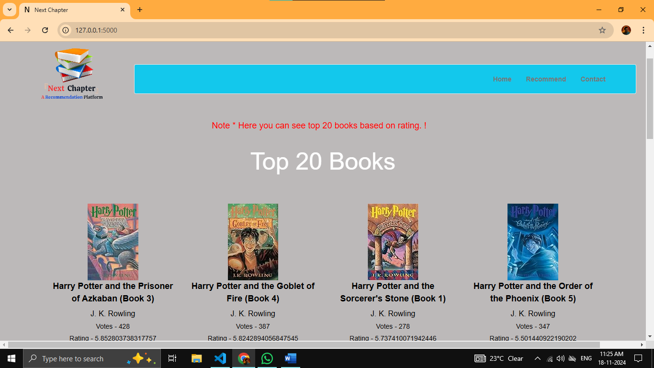

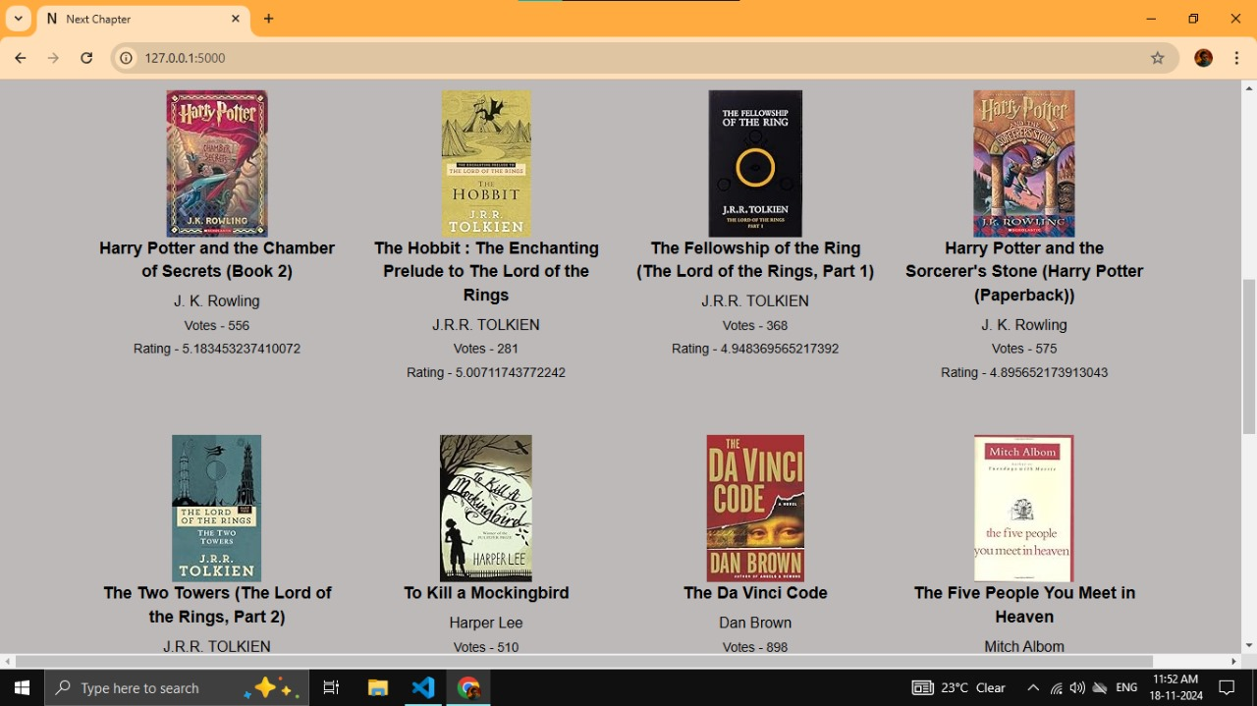**Figure 2 . Popularity based recommendation**

**Figure 3 . Top 20 Books**

**4.2 Recommend Books source code and output**

<!DOCTYPE html>

<html lang="en">

<head>

    <meta charset="UTF-8">

    <title>Recommend Books</title>

    <link rel="stylesheet" href="https://cdn.jsdelivr.net/npm/bootstrap@3.3.7/dist/css/bootstrap.min.css">

    <link rel="stylesheet" href="{{ url_for('static', filename='styles.css') }}">

    <link rel="icon" href="static/llogo.png" type="image/x-icon">

    <style>

        .container2 {

            max-width: 800px; /* Adjust width */

            margin: 0 auto; /* Center container */

            padding-right: 20px; /* Space from the right */

            padding-left: 20px; /* Optional: keep padding symmetric */

        }

        form {

            max-width: 750px; /* Limit form width */

            margin: 0 auto; /* Center it */

            padding-right: 10px; /* Reduce space on the right */

            padding-left: 10px; /* Optional: maintain symmetry */

        }

        .header-title {

            color: #fd0707; /* Change to your preferred color */

            font-size: 36px; /* Adjust font size */

            text-align: center;

            margin-top: -40px; /* Move heading slightly upward */

            font-family: 'Franklin Gothic Medium', 'Arial Narrow', Arial, sans-serif;

        }

        h2 {

    color: #f8690a; /* Change to your preferred color (e.g., green) */

    font-size: 28px; /* Optional: Adjust the font size */

    text-align: left; /* Optional: Center the text */

    margin-top: 20px; /* Optional: Adjust the space above */

    font-family: Impact, Haettenschweiler, 'Arial Narrow Bold', sans-serif;

}

    </style>

</head>

<body>

    <!-- Logo and Navbar Container -->

    <div class="logo-navbar-container">

        <!-- Logo Section -->

        <div class="logo-container">

            <img src="{{ url_for('static', filename='logo.png') }}" alt="Logo" class="logo">

        </div>

        <!-- Navbar -->

        <nav class="navbar navbar-default">

            <div class="container">

                <ul class="nav navbar-nav navbar-right">

                    <li><a href="/">Home</a></li>

                    <li><a href="/recommend">Recommend</a></li>

                    <li><a href="/contact">Contact</a></li>

                </ul>

            </div>

        </nav>

    </div>

    <div class="container2">

        <h1 class="header-title">Recommend Books</h1>

        {% if error %}

            <div class="alert alert-danger" role="alert">

                {{ error }}

            </div>

        {% endif %}

        <form action="/recommend_books" method="post">

            <div class="form-group">

                <label for="user_input">Enter Book Name:</label>

                <input type="text" name="user_input" id="user_input" class="form-control" placeholder="Enter Book Name" required>

            </div>

            <button type="submit" class="btn btn-primary">Submit</button>

        </form>

        {% if data %}

            <h2>Recommended Books</h2>

            <div class="row">

                {% for item in data %}

                    <div class="col-md-3 book-card">

                        <div class="card">

                            <img src="{{ item[2] }}" alt="{{ item[0] }}" class="card-img-top">

                            <p class="book-title">{{ item[0] }}</p>

                            <h4 class="book-author">{{ item[1] }}</h4>

                        </div>

                    </div>

                {% endfor %}

            </div>

        {% endif %}

    </div>

</body>

</html>

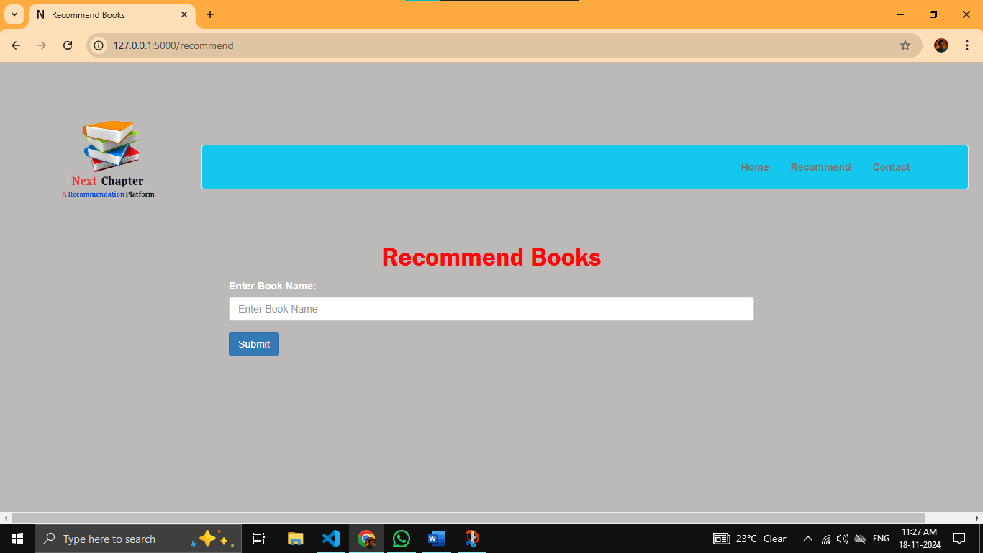**outputs:**

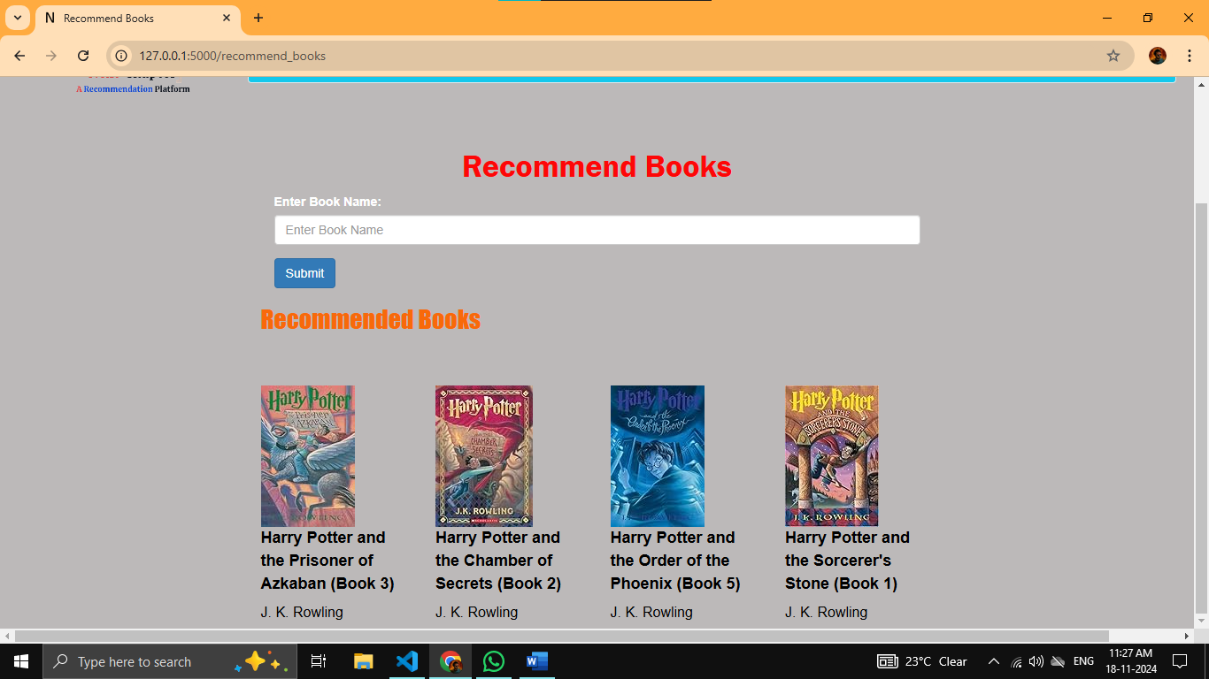**Figure 4. Recommendation Book Page before input**

**Figure 5. Recommendation Book Page after input**

**4.3 After enter wrong input in recommended box it will show**

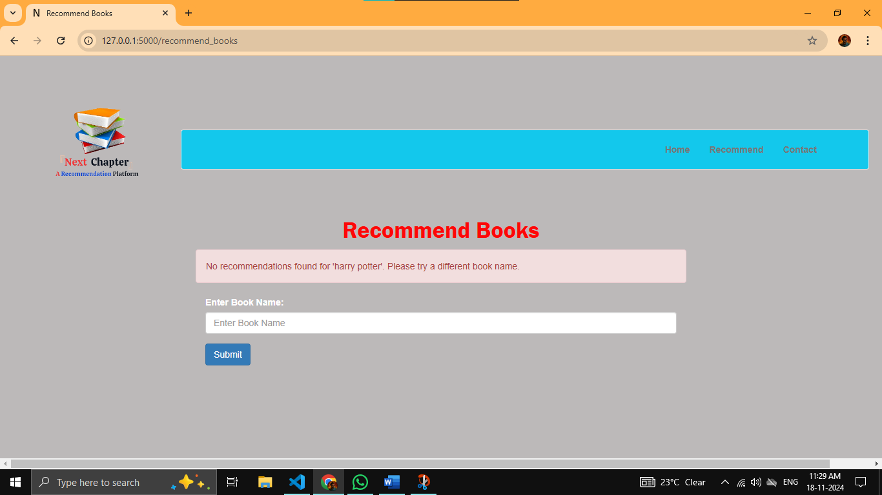

**Figure 6. After Entering wrong input**

**4.4 Contact page source code and output:**

<!DOCTYPE html>

<html lang="en">

<head>

    <meta charset="UTF-8">

    <title>Contact Us</title>

    <link rel="stylesheet" href="https://cdn.jsdelivr.net/npm/bootstrap@3.3.7/dist/css/bootstrap.min.css">

    <link rel="stylesheet" href="{{ url_for('static', filename='styles.css') }}">

    <link rel="icon" href="static/llogo.png" type="image/x-icon">

    <style>

        /* Move the "Contact Us" heading upwards */

        .header-title {

            font-size: 50px; /* Adjust font size if needed */

            text-align: center; /* Center the text */

            margin-top: -69px; /* Move it upwards by 20px */

            font-family: 'Trebuchet MS', 'Lucida Sans Unicode', 'Lucida Grande', 'Lucida Sans', Arial, sans-serif;

            color: black;

        }

        .container2 {

            max-width: 800px; /* Adjust width */

            margin: 0 auto; /* Center container */

            padding-right: 20px; /* Space from the right */

            padding-left: 20px; /* Optional: keep padding symmetric */

        }

  </style>

</head>

<body>

    <!-- Logo and Navbar Container -->

    <div class="logo-navbar-container">

        <!-- Logo Section -->

        <div class="logo-container">

            <img src="{{ url_for('static', filename='logo.png') }}" alt="Logo" class="logo">

        </div>

        <!-- Navbar -->

        <nav class="navbar navbar-default">

            <div class="container">

                <ul class="nav navbar-nav navbar-right">

                    <li><a href="/">Home</a></li>

                    <li><a href="/recommend">Recommend</a></li>

                    <li><a href="/contact">Contact</a></li>

                </ul>

            </div>

        </nav>

    </div>

    <div class="container2">

        <h1 class="header-title">Contact Us</h1>

        {% with messages = get_flashed_messages() %}

            {% if messages %}

                <div class="alert alert-success" role="alert">

                    {{ messages[0] }}

                </div>

            {% endif %}

        {% endwith %}

        <form action="/send_message" method="post">

            <div class="form-group">

                <label for="name">Name:</label>

                <input type="text" name="name" id="name" class="form-control" placeholder="Enter your name" required>

            </div>

            <div class="form-group">

                <label for="email">Email:</label>

                <input type="email" name="email" id="email" class="form-control" placeholder="Enter your email" required>

            </div>

            <div class="form-group">

                <label for="message">Message:</label>

                <textarea name="message" id="message" class="form-control" rows="5" placeholder="Enter your message" required></textarea>

            </div>

            <button type="submit" class="btn btn-primary">Send Message</button>

        </form>

    </div>

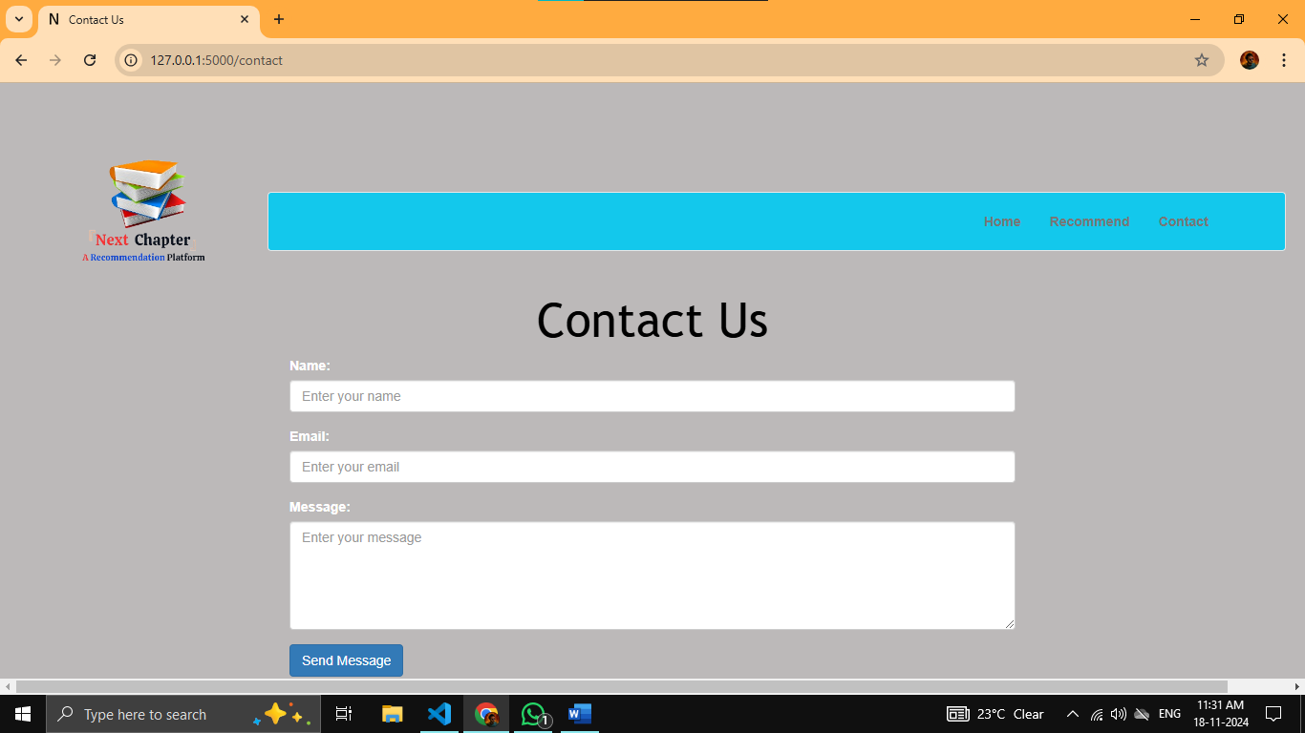</body>

</html>

**output:**

**Figure. 7 Contact Page**

**4.5 Other css part:**

body {

background-color: rgba(136, 131, 131, 0.562);

color: white;

}

.logo-navbar-container {

display: flex;

align-items: center;

justify-content: space-between;

padding: 10px 20px;

}

.logo-container {

flex-shrink: 0;

}

.logo {

width: 270px; /* Adjust logo size */

height: auto;

}

.navbar {

background-color: #13c8ec;

margin: 0 auto;

padding: 1px 4px; /* Reduced top and bottom padding */

text-align: center;

flex-grow: 1;

margin-left: -10px; /* Reduced from -50px to -20px to bring it closer to the left */

}

.navbar .container {

padding-left: 0; /* Remove default left padding */

margin-right: -150px;

margin-left: -20px; /* Adjusted to match the navbar box movement */

padding-top: 4px; /* Reduced top padding */

padding-bottom: 4px; /* Reduced bottom padding */

}

.navbar .navbar-nav {

text-align: center; /* Fixed typo: 'cent' to 'center' */

margin-right: 140px; /* Moves the entire navbar box slightly to the left */

}

.navbar a {

color: #333; /* Dark color for links */

font-weight: bold;

}

.navbar a:hover {

color: #fff; /* White color on hover */

}

.header-title {

font-size: 50px;

text-align: center;

margin-top: 20px;

}

.book-card {

margin-top: 50px;

}

.book-title {

color: #000000;

font-size: 18px;

font-weight: bold;

}

.book-author {

color: #000000;

font-size: 16px;

}

.book-votes, .book-rating {

color: #070707;

font-size: 14px;

}

.recommend-form {

margin-bottom: 30px;

}

.submit-btn {

margin-top: 10px;

}

.floating-line {

position: relative;

overflow: hidden; /* Hide the overflowing part of the text */

height: 35px; /* Adjust the height as needed */

width: 100%; /* Ensure the container takes full width */

margin-top: -55px; /* Reduce the gap above the note */

}

.note p {

margin: 0; /* Remove the default margin */

background: none; /* Remove the background */

color: #fd0404; /* Text color */

position: absolute; /* Make the element positioned relative to the container */

white-space: nowrap; /* Prevent line breaks */

animation: floatToLeft 15s linear infinite; /* Apply the animation */

top: -5px; /* Move the text slightly upward */

font-size: 18px; /* Increase font size */

}

@keyframes floatToLeft {

0% {

left: 100%; /* Start from outside the right edge */

}

100% {

left: -100%; /* Move to outside the left edge */

    }

}

**CHAPTER 5: SOFTWARE & HARDWARE REQUIREMENTS**

**Software Requirements**

Backend Development

* **F**ramework: Flask (for web application)
* Programming Language: Python (for recommendation logic, API development, etc.)
* Dataset:
  + Books.csv, rating.csv, user.csv
* Libraries:
  + Pandas, NumPy: Data processing and analysis
  + Scikit-learn: Machine learning for collaborative filtering
  + Flask-SQLAlchemy: For database integration
  + Jinja2: For HTML templating
  + Matplotlib/Seaborn: For visualizations (optional)

Frontend Development

* Languages: HTML, CSS, JavaScript
* Libraries/Frameworks:
  + Bootstrap (for responsive design)

Environment

* Development Tools:
  + IDE/Text Editor: Visual Studio Code, PyCharm, or Jupyter Notebook (used for the module development)
  + Version Control: Git

Other Tools

* Browser: Google Chrome, Firefox (for testing)

**Hardware Requirements**

Development Phase

* Processor: Intel i5 (8th Gen or above) or AMD Ryzen 5 equivalent
* Also i3
* RAM: 8 GB (you already have this; sufficient for small to medium datasets)
* Storage:
  + 256 GB SSD (for faster performance) or 1 TB HDD
* Graphics: Integrated graphics are sufficient

Testing/Deployment Phase

* For Local Testing: Same as development phase
* For Production:
  + Cloud Server with specifications depending on user traffic:
    - CPU: 2-4 cores (e.g., AWS t2.medium or higher)
    - RAM: 4 GB or higher
    - Storage: 50 GB SSD or higher
  + Scalable hosting with load balancing for high traffic

User Device Requirements

* Browser Support: Latest versions of Chrome, Firefox, Edge
* Internet: Broadband connection for accessing the web application

Other Tools

* Browser: Google Chrome, Firefox (for testing)

These requirements are based on the scale and features of your platform, as well as the tools you’ve used so far. If your dataset grows significantly, you might need more RAM and processing power. Let me know if you need further customizations!

**CHAPTER 6: REQUIREMENT ANALYSIS**

**6.1 System Requirement Specification –**

The development and deployment of a Book Recommendation System necessitate specific hardware and software configurations to ensure smooth functioning and scalability.

1.1 Functional Requirements

Data Handling: The system should efficiently manage large datasets containing millions of records related to books, users, and ratings.

Recommendation Algorithms:

Generate accurate recommendations based on popularity and user preferences.

Implement collaborative filtering to suggest personalized book options.

Web Interface:

Provide an intuitive and responsive interface.

Display recommendations dynamically as per user interactions.

Data Security: Safeguard user information, ensuring data privacy and integrity.

1.2 Non-Functional Requirements

Performance:

Recommendations should load within 1-2 seconds.

Ensure minimal latency even with high concurrent usage.

Reliability: The system should have robust error handling and maintain data consistency during operations.

Scalability: Capable of handling increasing numbers of users and books without significant performance degradation.

Usability: The interface should be user-friendly, with clear navigation and a clean design.

Compatibility:

The system should be compatible with major browsers (Chrome, Firefox, Safari, Edge).

Cross-platform operability for desktop and mobile devices.

1.3 Hardware Requirements

Development Environment:

Processor: Intel Core i5 or AMD Ryzen 5 (or higher).

RAM: Minimum 8 GB (16 GB recommended for larger datasets).

Storage: 500 GB SSD or HDD for storing datasets and processing files.

Deployment Environment:

Cloud Platform: AWS, Google Cloud, or Azure for scalability.

Server Specifications: Minimum 4-core processor, 16 GB RAM, and SSD for fast I/O operations.

1.4 Software Requirements

Operating System: Compatible with Windows 10 or higher, macOS, and major Linux distributions.

Programming Language: Python 3.x for its rich ecosystem of libraries and community support.

Web Framework: Flask, chosen for its simplicity and lightweight nature.

Database: PostgreSQL or MySQL for structured data management.

Libraries and Tools:

Pandas and NumPy for data preprocessing.

scikit-learn for implementing machine learning models.

Matplotlib and Seaborn for data visualization during analysis.

Pickle for saving and loading machine learning models.

Performance Requirements:

Response Time: The system should provide book recommendations within 2 seconds of user interaction, even during peak traffic.

Throughput: The platform should handle at least 500 concurrent users without degradation in performance.

**6.2 Software Tools Used –** The project relies on several software tools to manage, process, and deploy the recommendation system effectively.

2.1 Backend Development

Python:

Primary programming language for the project.

Provides extensive libraries for data analysis and machine learning.

Flask Framework:

Lightweight and suitable for developing web applications.

Simplifies routing, template rendering, and HTTP request handling.

Pickle Module:

Used for serializing and deserializing Python objects.

Ensures quick storage and retrieval of preprocessed data and models.

2.2 Data Processing and Analysis

Pandas:

For data cleaning, manipulation, and exploration.

Essential for handling large datasets efficiently.

NumPy:

Offers fast numerical computations.

Enables matrix operations, which are critical for collaborative filtering.

scikit-learn:

Used for implementing machine learning algorithms like cosine similarity.

Provides tools for model evaluation and metrics.

2.3 Frontend Development

Bootstrap:

Ensures a responsive and visually appealing user interface.

Simplifies layout design with prebuilt components and grid systems.

HTML, CSS, and JavaScript:

HTML for structuring web pages.

CSS for styling and improving the visual aesthetics.

JavaScript for enhancing interactivity.

2.4 Database and Storage

PostgreSQL/MySQL:

For managing structured datasets, including user details, book information, and ratings.

Ensures data consistency and supports complex queries.

CSV Files:

Store raw datasets, including books, users, and ratings.

Provide a simple format for initial data loading.

2.5 Deployment and Collaboration

Git and GitHub:

For version control and collaborative development.

Facilitates team management and tracking code changes.

Cloud Platforms (Optional for Deployment):

AWS, Azure, or Google Cloud for scalable deployment.

Enable dynamic scaling based on user traffic and data size.

2.6 Visualization Tools

Matplotlib and Seaborn:

Used for exploratory data analysis and understanding trends in the datasets.

Aid in identifying patterns and anomalies before model training.

2.7 IDE and Development Environment

1. VS Code (Visual Studio Code)

Overview: Visual Studio Code (VS Code) is the preferred Integrated Development Environment (IDE) for the project due to its lightweight nature, versatility, and extensive plugin ecosystem. It is well-suited for full-stack development, offering powerful features that streamline the coding, debugging, and deployment processes.

Features and Benefits:

Lightweight and Fast: VS Code is optimized for speed and performance, making it an ideal choice for resource-constrained environments like laptops with 8GB RAM.

Extensive Plugin Support:

Extensions such as Python, Prettier, Live Server, and Jupyter Notebook improve productivity and enhance the coding experience.

Database extensions like PostgreSQL enable seamless database integration and management.

Version control extensions like GitLens simplify tracking code changes and collaboration.

Integrated Debugging Tools:

Built-in debugging features support Python, JavaScript, and other languages, making it easier to identify and fix issues.

Breakpoints, variable inspection, and step-through execution ensure efficient debugging.

Version Control Integration:

VS Code integrates seamlessly with Git and GitHub, facilitating version control, collaborative coding, and easy rollback of changes.

Provides visual tools for managing branches, staging changes, and resolving merge conflicts.

Customizable Environment:

Developers can personalize the editor with themes, key bindings, and settings tailored to their workflow.

Real-Time Collaboration:

Extensions like Live Share enable real-time code collaboration among team members, fostering efficient teamwork.

Usage in the Project:

Writing and testing the backend logic in Python using Django for the web application.

Creating and editing HTML, CSS, and JavaScript files for the frontend interface.

Managing project versioning and team collaboration through Git and GitHub.

2. Jupyter Notebook

Overview: Jupyter Notebook is a web-based interactive computing platform, ideal for data analysis, visualization, and prototyping machine learning models. It complements VS Code by providing an environment tailored to experimenting with data and testing algorithms iteratively.

Features and Benefits:

Interactive Data Exploration:

Allows the execution of code in cells, enabling quick testing and debugging of individual code snippets.

Displays outputs directly below the code, including visualizations, making data exploration intuitive.

Machine Learning Model Development:

Supports Python libraries like Pandas, NumPy, Matplotlib, Seaborn, and Scikit-learn for data preprocessing, visualization, and machine learning.

Easy integration with advanced libraries like TensorFlow or PyTorch for model prototyping and training.

Documentation and Code in One Place:

Combines code, markdown, and visualizations in a single notebook, making it an excellent tool for documentation and presentation.

Markdown cells support LaTeX for mathematical equations, enhancing documentation quality.

Extensibility:

Supports a variety of kernels, allowing the use of languages beyond Python, such as R and Julia

**6.3 MACHINE LEARNING ALGORITHM**

The Book Recommendation System employs two primary machine learning techniques: Popularity-Based Filtering and Collaborative Filtering. Both approaches are implemented to provide diverse and accurate recommendations for users. Below is a detailed explanation of these algorithms:

**Popularity-Based Recommender System**

Overview:The Popularity-Based Recommender System suggests books based on their overall popularity, without considering the user's preferences. It is a simple and effective baseline algorithm.

Steps Involved:

Data Aggregation:The ratings dataset is merged with the books dataset to include book details such as title, author, and image URLs.Group the data by book titles to calculate the total number of ratings (num_ratings) and the average rating (avg_rating) for each book.

Filtering: Books with fewer than a predefined number of ratings (e.g., 250) are excluded to ensure that only widely reviewed books are considered.

Sorting: The remaining books are sorted in descending order of their average ratings.The top N books (e.g., 50) are selected as the most popular.

Advantages:

Simple to implement and interpret.

Does not require user-specific data.

Suitable for new users (cold-start problem).

Disadvantages:

Lacks personalization; all users receive the same recommendations.

Ignores user preferences and behavioral data.

The Popularity-Based Recommendation Algorithm is a simple yet effective approach to recommending items based on their overall popularity. It does not rely on user-specific data but instead suggests items that are generally well-liked or highly rated by the majority of users

**Collaborative Filtering Using Cosine Similarity**

Overview:

Collaborative Filtering uses the collective behavior of users to recommend books. It relies on the assumption that users with similar preferences will like similar items. In this project, item-based collaborative filtering is implemented using cosine similarity.

Filter the dataset to include:

Users who have rated a significant number of books (e.g., more than 200 ratings).

Books that have received a significant number of ratings (e.g., at least 50 ratings).

Create a pivot table (PT) where rows represent book titles, columns represent user IDs, and the cells contain ratings. Missing values are filled with 0.

Cosine Similarity: Compute the similarity between all book pairs using cosine similarity. This metric calculates the cosine of the angle between two vectors (e.g., rating vectors of two books):

Recommendation Generation: For a given book, find its nearest neighbors (most similar books) based on cosine similarity scores.

Exclude the input book itself to avoid recommending the same book.

Retrieve details (e.g., title, author, and image) of the top N most similar books.

Output: Return a list of similar books as recommendations for the input book.

Advantages:

Personalized recommendations based on user preferences.

Captures hidden patterns in user behavior and item similarity.

Disadvantages:

Computationally intensive for large datasets.

Struggles with sparsity in user-book interaction data.

Faces the cold-start problem for new books and users.

**6.4 Applications**

The *Next Chapter* platform has a wide range of applications that can significantly enhance the book discovery experience for readers. By leveraging machine learning and data-driven approaches, the system is designed to provide personalized book recommendations, improving the overall reading journey. Below are some key applications of the platform:

1. Personalized Book Recommendations

* Target Audience: Readers looking for book suggestions based on their past preferences and interests.
* How It Works: The system utilizes collaborative filtering and popularity-based algorithms to suggest books that align with the user’s reading history or preferences. The recommendations are tailored to the individual, offering a personalized experience that ensures users discover books that match their interests.
* Benefits: By analyzing user behavior and ratings, the platform helps users find books they might not have otherwise encountered, enhancing the overall reading experience.

2. AI-Based Job Matching for Literary Professionals

* Target Audience: Authors, publishers, and literary professionals.
* How It Works: Beyond just book recommendations, the platform can be extended to suggest career opportunities, collaborations, and publishing platforms based on users’ professional interests and past work.
* Benefits: Helps literary professionals find relevant career opportunities and connect with publishers or other writers with similar themes or interests, leveraging the system’s AI capabilities.

3. Discovering New Genres

* Target Audience: Users interested in exploring new genres or themes.
* How It Works: Based on reading history and ratings, the platform can suggest books from genres or topics that the user has not previously explored but aligns with their interests.
* Benefits: Encourages users to explore diverse literary genres, expanding their knowledge and appreciation for different styles of writing.

4. Enhanced User Engagement and Interaction

* Target Audience: Active readers who want a more interactive experience.
* How It Works: The platform allows users to rate books, leave reviews, and track their reading progress. Personalized dashboards can display books the user has read, ratings, and new suggestions based on their preferences.
* Benefits: Increases user engagement by giving users control over their reading experience and motivating them to explore books, track progress, and share opinions with other readers.

5. Social and Community Integration

* Target Audience: Readers who want to share their reading experiences with others.
* How It Works: The platform can be integrated with social media channels, allowing users to share book recommendations, reviews, and reading achievements. It can also allow users to follow friends or other readers for shared recommendations.
* Benefits: Facilitates a sense of community by connecting users with similar reading tastes, fostering collaboration, and encouraging the exchange of ideas and reviews.

6. Book Clubs and Group Recommendations

* Target Audience: Book clubs, discussion groups, and educational institutions.
* How It Works: The platform can recommend books based on collective preferences of a group or community, making it ideal for book clubs or study groups.
* Benefits: Streamlines the book selection process for group discussions, ensuring that all members get books that are of collective interest, enhancing group cohesion and learning.

7. Educational Tool for Learning and Research

* Target Audience: Students, educators, and researchers.
* How It Works: The platform can be used as an educational resource to recommend academic books, research papers, or textbooks based on the user’s field of study or

**6.5 Advantages**

1. Personalized User Experience
   * Description: One of the main advantages of the *Next Chapter* platform is its ability to provide personalized book recommendations based on user behavior and preferences. By leveraging machine learning techniques such as collaborative filtering and popularity-based methods, the platform ensures that users receive suggestions that align with their reading habits.
   * Benefit: This enhances the overall reading experience by guiding users toward books that match their individual tastes, helping them discover books they might have overlooked otherwise.
2. Improved Book Discovery
   * Description: The platform's recommendation engine increases the visibility of a wide variety of books, not only those from mainstream authors or publishers but also lesser-known works. By using algorithms that analyze user ratings, reviews, and reading patterns, the system introduces users to new genres and authors.
   * Benefit: Readers are exposed to a broader spectrum of content, leading to more diverse reading experiences and enabling them to explore books outside their usual preferences, thus fostering a more dynamic literary culture.
3. AI-Powered Efficiency
   * Description: The incorporation of AI-based algorithms allows the platform to make recommendations efficiently and with a high degree of accuracy. As users interact with the system, the AI learns their preferences and adapts its suggestions over time.
   * Benefit: The continuous learning process ensures that the recommendations improve as the user engages with the platform, leading to an increasingly relevant and satisfying book discovery experience.
4. Scalability
   * Description: The *Next Chapter* platform can handle a wide range of users and datasets without compromising performance. Whether a small group of readers or a large-scale audience, the system is designed to scale as the number of users and books grows.
   * Benefit: This scalability makes the platform suitable for both personal use and larger communities, such as book clubs, educational institutions, or even commercial use by publishers or retailers.
5. Enhanced User Engagement
   * Description: By incorporating features such as ratings, reviews, and personalized dashboards, the platform encourages users to engage actively with the system. Users can track their reading history, share recommendations with friends, and discover new books based on their interactions.
   * Benefit: These features increase user interaction and satisfaction, making the platform more engaging and keeping users motivated to continue exploring new books and providing valuable feedback.
6. Social Integration
   * Description: The platform can be integrated with social media channels to allow users to share their reading achievements, reviews, and recommendations with friends. This creates a sense of community and fosters user-driven content.
   * Benefit: Social integration drives organic growth and brings more users to the platform, as people are more likely to trust recommendations from friends and peers.
7. Valuable Insights for Authors and Publishers
   * Description: The platform’s data-driven approach provides authors and publishers with valuable insights into what types of books are popular among specific audiences. By analyzing user preferences, the platform can guide marketing strategies and help authors identify target audiences for their works.
   * Benefit: Authors and publishers can optimize their marketing efforts, target the right demographics, and even tailor content to better meet the needs of their readers.
8. Supports Diverse User Groups
   * **Description**: *Next Chapter* is designed to cater to a wide variety of readers, from casual readers to academic researchers. By offering genre-specific recommendations and integrating advanced search features, the platform can serve different niches and user types.
   * **Benefit**: The platform's versatility makes it appealing to diverse audiences, from individuals looking for entertainment to those seeking educational content.

**6.6 Disadvantages**

1. Dependence on Data Quality
   * Description: The accuracy and effectiveness of the recommendation algorithms are heavily dependent on the quality of the data they receive. Incomplete, biased, or inaccurate data can lead to poor recommendations that may not align with the user’s actual preferences.
   * Drawback: If the system lacks sufficient user input or if the data is skewed, the recommendations may not be relevant, leading to user frustration and a diminished user experience.
2. Data Privacy Concerns
   * Description: Like any platform that collects user data, the *Next Chapter* system must handle personal information responsibly. Users may be concerned about how their reading habits, preferences, and personal data are stored and shared.
   * Drawback: There is always the risk of privacy violations or data breaches, which can erode user trust and discourage engagement. Ensuring that the platform complies with data protection regulations, such as GDPR, is essential.
3. Overfitting of Recommendations
   * Description: A potential issue with recommendation systems is overfitting, where the algorithm may suggest books based on too narrow of a dataset. For example, if a user’s reading history is limited to a few genres or authors, the system might overly rely on this data and fail to introduce fresh or diverse recommendations.
   * Drawback: This can result in repetitive suggestions that don’t expose the user to new or varied content, ultimately reducing the platform's effectiveness in broadening the user’s reading horizon.
4. Algorithm Bias
   * Description: Recommendation algorithms are susceptible to bias, either from the data they are trained on or from the way the system is designed. If the platform relies on popular books or heavily rated content, it may disproportionately suggest mainstream titles, ignoring niche or independent books.
   * Drawback: This bias can reduce the platform's appeal to users who are seeking a broader range of options, especially those interested in less mainstream or indie publications.
5. Limited Interactivity
   * Description: Although *Next Chapter* offers basic interactive features such as rating and reviewing, it may lack deeper interactivity compared to other platforms. For example, there might not be enough user-driven content, like discussion forums or group reading features, to foster a sense of community.
   * Drawback: A lack of interactive elements can make the platform feel more transactional rather than engaging, potentially lowering user retention.
6. Recommendation Saturation
   * Description: As users continue to engage with the platform, they might encounter recommendation fatigue, where the system continuously suggests books from a limited set of categories or authors. This can lead to a sense of saturation, especially if the algorithm does not introduce enough variety or novelty.
   * Drawback: Over time, users may become less interested in the platform if the recommendations feel repetitive or irrelevant, diminishing the long-term value of the system.

**CHAPTER 7: RESULT**

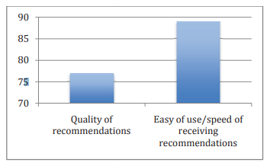

**Figure. 8 Experiment Result**

**Quality of Recommendations** and **Ease of Use/Speed of Receiving Recommendations**. The vertical axis represents the performance scores, while the horizontal axis categorizes the evaluation metrics.

From the chart, it is evident that the **Ease of Use/Speed of Receiving Recommendations** scored significantly higher, reaching close to 90. This indicates that the system performs exceptionally well in terms of responsiveness and user-friendliness, delivering recommendations quickly and efficiently.

On the other hand, the **Quality of Recommendations** achieved a slightly lower score, around 75. While this is a positive result, it suggests there is room for improvement in accurately matching user preferences or refining the algorithms used for recommendations.

These results highlight that while the system is easy to use and provides recommendations promptly, enhancing the quality of suggestions can further improve overall user satisfaction and system effectiveness. Future iterations could focus on fine-tuning the recommendation algorithms, potentially incorporating more user feedback or advanced AI techniques.

The experiment results demonstrate a strong foundation for the recommendation system, particularly in terms of usability and performance. The higher score for **Ease of Use/Speed** reflects that users can interact with the platform seamlessly, which is crucial for retaining engagement and ensuring a positive user experience.



**Figure. 9 Before Recommendation**

**Figure. 10 Recommendation Results**

**CHAPTER 8: CONCLUSION**

**8.1 Conclusion**

The Book Recommendation System is a robust and practical application designed to enhance the user experience in discovering books. By leveraging two distinct recommendation strategies — Popularity-Based Filtering and Collaborative Filtering, the system caters to both general users and those seeking personalized recommendations. Here are the key takeaways from the project:

1. Effective Dual Approach:
   * The Popularity-Based System provides a quick way to display trending books, ensuring that all users have access to highly rated and widely liked options.
   * The Collaborative Filtering System introduces personalization by analyzing user preferences and suggesting books that align with their tastes.
2. Scalability and Usability
   * The system is scalable and capable of handling a large number of users and books, thanks to efficient data preprocessing and similarity computation.
   * The use of web technologies such as Flask ensures that the recommendation system is easily accessible through a user-friendly interface.
3. Significant Impact:
   * The system bridges the gap between vast book collections and user preferences, saving users time and effort in selecting books.
   * It demonstrates the practical application of machine learning in everyday scenarios, showcasing how data-driven insights can enhance decision-making.
4. Achievements:
   * Successfully implemented data preprocessing pipelines to clean, filter, and transform data.
   * Created a fully functional web application that integrates machine learning models with a responsive front-end interface.

The Next Chapter platform successfully demonstrates the potential of leveraging machine learning and user-centric design to enhance the book discovery experience. By utilizing collaborative filtering and popularity-based methods, the system provides personalized and general recommendations, ensuring a versatile user experience that caters to both avid and casual readers.

The integration of Flask as the web framework enabled seamless interaction between the user interface and the recommendation algorithms, ensuring dynamic content delivery. Using Jupyter Notebook for the development of the recommendation module facilitated iterative testing and refinement of the models, resulting in more accurate and relevant suggestions. The inclusion of AI-driven techniques adds a layer of sophistication, aligning the recommendations with users' unique reading preferences.

Through the project's development, critical technical and problem-solving skills were honed, including data preprocessing, model training, and web application deployment. Additionally, incorporating visual and user-friendly elements like a logo and intuitive navigation enhanced the platform's appeal, offering an enjoyable experience for end users.

This project lays the groundwork for further enhancements, such as integrating a content-based filtering model, enabling real-time user feedback, and incorporating multilingual support to reach a broader audience. By continuing to refine and expand its capabilities, Next Chapter has the potential to become a comprehensive and widely used book recommendation platform.

In conclusion, this project not only serves as a practical solution for readers seeking personalized book suggestions but also exemplifies the effective application of data science and web development technologies in solving real-world problems. It represents a valuable addition to the portfolio and a significant milestone in the academic and professional journey.

Furthermore, the project highlights the importance of bridging technology and user experience to create impactful applications. By blending machine learning algorithms with an intuitive web interface, Next Chapter has successfully demonstrated how data-driven insights can enrich users' lives. The platform’s adaptability to diverse datasets and its potential for integrating emerging technologies, such as natural language processing for book summaries or sentiment analysis for reviews, positions it as a scalable solution.

**CHAPTER 9 : FUTURE SCOPE**

**9.1 Further Scope**

While the current system is functional and valuable, there are several opportunities for enhancement and expansion. These include:

1. Incorporating Advanced Algorithms

* Implementing Matrix Factorization Techniques such as Singular Value Decomposition (SVD) or Alternating Least Squares (ALS) to improve the accuracy of collaborative filtering.
* Exploring Deep Learning Approaches like Autoencoders or Neural Collaborative Filtering to capture non-linear relationships between users and books.

2. Addressing Cold-Start Problems

* For new users: Introduce content-based filtering using user-provided attributes like favorite genres or authors.
* For new books: Leverage metadata such as genre, keywords, and synopsis to recommend books based on their content.

3. Enhancing User Interactivity

* Enable users to rate books directly within the system, creating a continuous feedback loop to improve recommendations.
* Incorporate social features such as book reviews, user comments, and ratings.

4. Expanding the Dataset

* Integrate datasets from external sources (e.g., Goodreads API) to include more diverse and up-to-date book information.
* Add multilingual support to cater to non-English speaking audiences.

1. Performance Optimization

Use clustering techniques to reduce computational overhead by grouping similar users or books before similarity computations..

**CHAPTER 10: REFERENCES**

**OpenAI's ChatGPT**

The development of this project was significantly guided by OpenAI's ChatGPT, an advanced AI-based conversational model. ChatGPT provided us with valuable insights, technical explanations, and suggestions for implementing various components of the recommendation system. <https://chat.openai.com/>.

ChatGPT, developed by OpenAI, is a state-of-the-art language model based on the GPT-4 architecture. It serves as an intelligent conversational assistant, providing real-time insights, technical guidance, and creative inputs across a broad spectrum of topics. For our project, ChatGPT was utilized as a reference tool to streamline development and ensure comprehensive understanding of the domain.

Purpose of Using ChatGPT:

1. Technical Guidance: To clarify concepts related to project implementation, such as frameworks, algorithms, and coding standards.
2. Problem-Solving: To debug errors and identify optimal solutions during development.
3. Idea Generation: To brainstorm innovative features and strategies for project enhancement.
4. Documentation Support: To structure project reports, user manuals, and technical documentation.

Applications in the Project:

1. Conceptual Understanding: ChatGPT explained complex topics such as AI algorithms, API integration, and database optimization.
2. Code Assistance: Provided snippets for implementing key features, including user authentication, file handling, and data visualization.
3. User-Centric Design**:** Helped refine the UI/UX aspects by offering suggestions aligned with modern design principles.
4. Testing Strategies: Assisted in designing test cases for functional and performance testing.

**Kaggle for Datasets**

To build the Book Recommendation System, we sourced our dataset from Kaggle, a leading platform for data science and machine learning. Kaggle offers a vast repository of high-quality datasets across different domains, making it an excellent resource for data-driven projects. The dataset used in this project provided a rich and diverse set of information, crucial for training and evaluating the recommendation model. Visit https://www.kaggle.com/ to explore its resources.

Kaggle is a renowned platform offering datasets, coding environments, and a collaborative community for data science and machine learning enthusiasts. It played a pivotal role in our project by providing access to high-quality datasets, prebuilt notebooks, and insightful discussions. Leveraging Kaggle's resources enabled us to build a robust, data-driven solution efficiently.

Purpose of Using Kaggle:

1. Access to Datasets: To source reliable and diverse datasets relevant to the project.
2. Code Exploration: To review and adapt pre-existing code and notebooks for implementing machine learning and AI techniques.
3. Learning from Experts: To gain insights from the community forums and kernels shared by seasoned data scientists.
4. Benchmarking: To compare our approach with those used in similar problems on Kaggle.

Applications in the Project:

1. Data Sourcing: Kaggle was the primary source for obtaining high-quality, structured datasets.
2. Preprocessing Guidance: Leveraged Kaggle notebooks to learn efficient techniques for data cleaning and feature engineering.
3. Algorithm Implementation: Reviewed top-performing solutions to understand and implement advanced machine learning models.
4. Evaluation Metrics: Studied metrics used in Kaggle competitions to evaluate model performance.

**Streamlit Documentation**

The official documentation for Streamlit, available at https://docs.streamlit.io/, was instrumental in designing the project’s user interface. Streamlit is a lightweight and user-friendly framework that simplifies the process of creating interactive web applications. The documentation provided clear explanations, code examples, and best practices, enabling us to efficiently integrate the frontend with the recommendation system.

Streamlit is an open-source Python library designed to create intuitive and interactive web applications for data visualization and machine learning models. It was a crucial tool in our project, enabling us to build a dynamic user interface that made complex data accessible and actionable. With Streamlit, we transformed raw data into an engaging, user-friendly application with minimal effort.

Purpose of Using Streamlit:

1. Rapid Prototyping: To quickly build and test interactive components for the project.
2. Visualization: To display insights and predictions through intuitive graphs and charts.
3. Ease of Integration: To seamlessly integrate machine learning models into a web-based interface.
4. User Engagement: To create an interactive environment for users to explore data and outputs.

Applications in the Project:

1. User Interface: Built an interactive dashboard allowing users to upload files, select parameters, and view results in real time.
2. Data Visualization: Used Streamlit's built-in libraries to generate dynamic plots, such as bar charts, line graphs, and heatmaps.
3. Model Integration: Deployed machine learning models, enabling users to make predictions and analyze outputs directly from the web app.
4. Custom Widgets: Created sliders, dropdown menus, and buttons for a seamless user experience.

**Visual Studio Code (VS Code)**

Visual Studio Code, a lightweight yet powerful code editor, served as the primary Integrated Development Environment (IDE) for our project. Its extensive plugin ecosystem, debugging tools, <https://code.visualstudio.com/>.

Visual Studio, developed by Microsoft, is a comprehensive Integrated Development Environment (IDE) designed to support the development of software applications, websites, and services. In our project, Visual Studio was instrumental in managing code efficiently, debugging, and integrating various components, ensuring a streamlined development process.

Purpose of Using Visual Studio:

1. Code Development: To write, edit, and manage project code with advanced editing tools.
2. Debugging: To identify and resolve errors using its powerful debugging capabilities.
3. Integration Support: To integrate different libraries, frameworks, and tools seamlessly.
4. Version Control: To manage source code with built-in Git support.

Applications in the Project:

1. Code Management: Used Visual Studio’s intelligent code editor for syntax highlighting, auto-completion, and error checking.
2. Debugging and Testing: Leveraged the debugging tools to identify runtime errors and test functionality in real time.
3. Project Organization: Utilized project templates and folder structures to organize files and modules systematically.
4. Extensions: Installed extensions like Python, C#, or web development tools to enhance the IDE’s functionality according to project requirements.

Advantages of Using Visual Studio:

* Comprehensive IDE: Offers a one-stop solution for coding, testing, and debugging.
* User-Friendly Interface: Intuitive design with powerful features for beginners and advanced developers alike.

**Jupyter Notebook**

The machine learning model was developed and fine-tuned using Jupyter Notebook, a versatile platform for data analysis and visualization. Jupyter’s interactive environment allowed us to experiment with algorithms, preprocess data, and visualize results in an iterative and efficient manner. The notebook's ability to combine code, markdown, and visuals in a single interface proved invaluable for prototyping. Learn more at <https://jupyter.org/>.

Jupyter Notebook is an open-source, web-based interactive computing environment that supports programming languages like Python, R, and Julia. It played a critical role in our project by facilitating exploratory data analysis, iterative development, and seamless visualization. Its interactive features enabled us to document and execute code in real time, making the development process more efficient.

Purpose of Using Jupyter Notebook:

1. Exploratory Data Analysis: To analyze datasets interactively and visualize results immediately.
2. Documentation: To integrate code, visualizations, and narrative text in a single environment.
3. Rapid Prototyping: To quickly test and refine algorithms and logic.
4. Visualization: To create and render detailed charts, graphs, and plots for better insights.

Applications in the Project:

1. Data Preprocessing: Cleaned and transformed raw datasets within the notebook environment.
2. Model Development: Developed and evaluated machine learning models interactively, adjusting parameters and observing results in real time.
3. Visualization: Used libraries like Matplotlib, Seaborn, and Plotly to generate insightful visual representations of data.
4. Documentation: Created a step-by-step walkthrough of the project, combining code cells, outputs, and Markdown explanations.

**Using Flask as a Framework in a Project**

Flask is a lightweight and versatile web framework for Python, designed for building scalable and secure web applications. Known for its simplicity and flexibility, Flask allows developers to create robust backends and seamlessly integrate front-end elements. In our project, Flask served as the backbone for managing server-side logic, routing, and API integration, enabling us to deliver a dynamic and user-friendly application.

Why Flask Was Chosen:

1. Lightweight and Modular: Flask’s micro-framework design allows for selective inclusion of libraries and tools, avoiding unnecessary complexity.
2. Ease of Use: Simple to set up and suitable for projects of any scale.
3. Customizability: Offers the flexibility to design the application structure as needed.
4. Active Community**:** Supported by extensive documentation and a vibrant developer community for troubleshooting and enhancements.

Applications in the Project:

1. Routing and URLs: Flask’s routing system was used to define URL paths for various pages and endpoints in the application.
   * Example: Implemented routes like /login, /signup, and /dashboard for user navigation.
2. Backend Logic: Managed core server-side functionality, such as handling user requests and processing forms.
3. Database Integration: Used Flask extensions like Flask-SQLAlchemy to interact with the PostgreSQL database for managing user and job data.
4. Template Rendering: Leveraged Jinja2 templating engine to dynamically render HTML pages based on user inputs and backend logic.
5. API Integration: Integrated third-party APIs for additional functionality, such as AI-based job matching or recommendation features.
6. Error Handling: Configured custom error pages to enhance the user experience and manage exceptions gracefully.

Advantages of Using Flask:

1. Lightweight Framework: Minimal setup with the freedom to choose specific libraries and extensions.
2. Scalability: Suitable for small projects and scalable enough for complex applications.
3. Integration-Friendly: Works seamlessly with front-end technologies like HTML, CSS, and JavaScript.
4. Development Speed: Accelerated project development with built-in features and extensions like Flask-WTF for form handling and Flask-Migrate for database migrations.

Flask Extensions Used:

* Flask-SQLAlchemy: Simplified database management and query execution.
* Flask-WTF: Enabled secure and efficient form handling with CSRF protection.
* Flask-Migrate: Managed database migrations during development.
* Flask-Login: Implemented user authentication and session management.

Project Features Built with Flask:

* User Authentication: Implemented secure login and registration using Flask-Login and hashed passwords.
* Dynamic Content: Rendered personalized pages for users based on their data and interactions.
* AI Integration: Designed an AI-based resume matching system by connecting Flask with machine learning models.